# 13. Chemkin Simulation

## A)

Plotted below is the mole fraction of NO versus equivalence ratio for two reaction times, 1 ms and 10 ms. Clearly, the reaction time affects both the magnitude of the mole fraction of NO, as well as the equivalence ratio at which it reaches its peak.

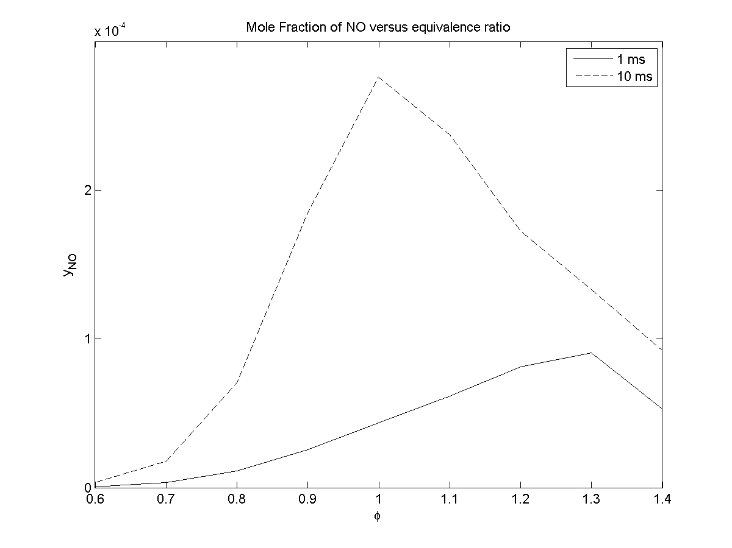

## B)

The classical Extended Zeldovich Mechanism underpredicts the resulting mole fraction of NO as compared to the full NOx mechanism, for both reaction times.

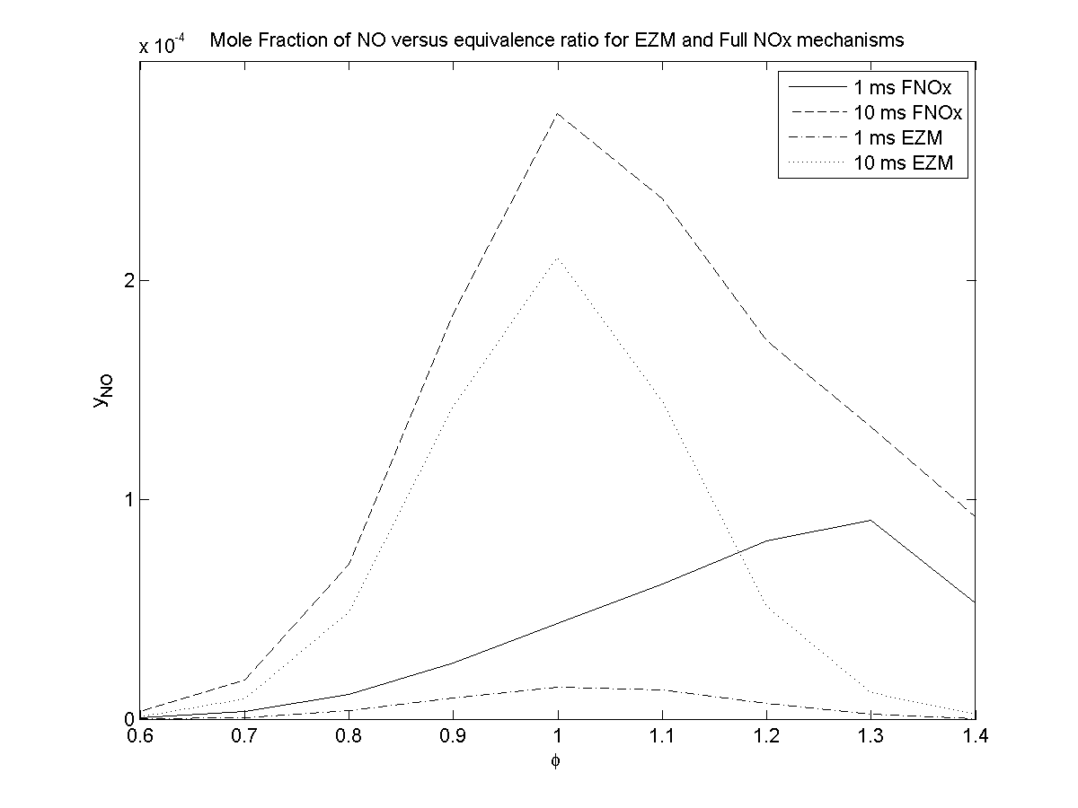

## C)

The reaction temperature is found to be consistently lower for the faster reaction. Both reaction times result in peak temperatures for slightly rich mixtures.

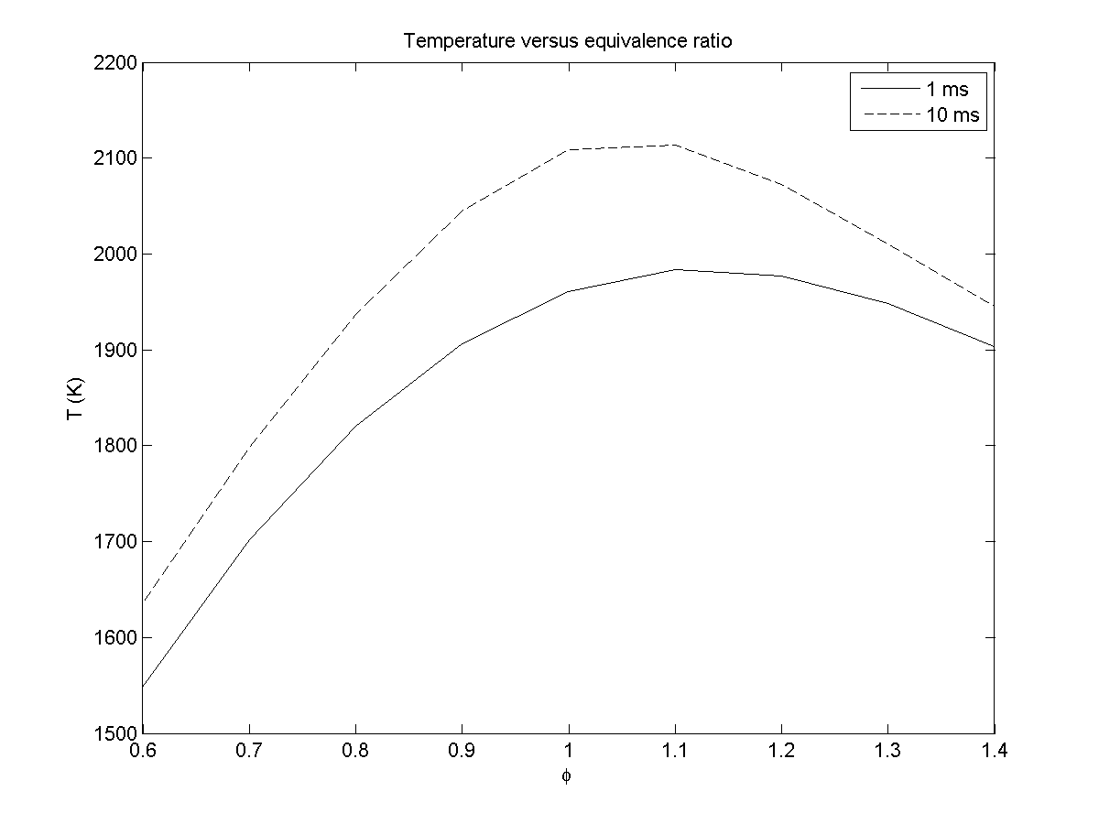

## D)

The major products of combustion, as well as CO and OH are plotted for reaction times of 1 and 10 ms. Both reaction times produce identical trends, and similar magnitudes for the mole fractions of the selected species. Interestingly, the mole fraction of OH radicals peaks at a slightly lean equivalence ratio; the cause of this is unclear. The slower reaction time results in lower levels of nitrogen and oxygen (molecular), as one would expect given the higher temperatures observed previously.

|  |  |
| --- | --- |
| I:\Work Backup\Matlab\Coursework\ME 726\HW5\Part D.png | I:\Work Backup\Matlab\Coursework\ME 726\HW5\Part D2.png |

## Tabulated Data

### Table A: Full NOx Mechanism

|  |  |  |  |  |  |  |  |  |  |
| --- | --- | --- | --- | --- | --- | --- | --- | --- | --- |
| R Time | phi | T (K) | CO2 | CO | O2 | OH | H2O | NO | N2 |
| 1 | 0.6 | 1548.1 | 0.0492 | 0.0092 | 0.0833 | 0.0029 | 0.1133 | 7.87E-07 | 0.7373 |
| 1 | 0.7 | 1702.3 | 0.0581 | 0.0095 | 0.0627 | 0.0048 | 0.1290 | 3.58E-06 | 0.7285 |
| 1 | 0.8 | 1820.4 | 0.0638 | 0.0125 | 0.0448 | 0.0064 | 0.1430 | 1.12E-05 | 0.7185 |
| 1 | 0.9 | 1906.8 | 0.0665 | 0.0180 | 0.0297 | 0.0075 | 0.1551 | 2.54E-05 | 0.7074 |
| 1 | 1 | 1961.2 | 0.0663 | 0.0260 | 0.0178 | 0.0078 | 0.1648 | 4.36E-05 | 0.6952 |
| 1 | 1.1 | 1983.9 | 0.0632 | 0.0364 | 0.0095 | 0.0071 | 0.1717 | 6.18E-05 | 0.6818 |
| 1 | 1.2 | 1977.3 | 0.0578 | 0.0485 | 0.0045 | 0.0054 | 0.1752 | 8.14E-05 | 0.6675 |
| 1 | 1.3 | 1948.4 | 0.0509 | 0.0615 | 0.0024 | 0.0033 | 0.1752 | 9.07E-05 | 0.6530 |
| 1 | 1.4 | 1903.7 | 0.0434 | 0.0738 | 0.0024 | 0.0015 | 0.1727 | 5.28E-05 | 0.6391 |
| 10 | 0.6 | 1635.4 | 0.0571 | 0.0020 | 0.0795 | 0.0020 | 0.1166 | 3.55E-06 | 0.7415 |
| 10 | 0.7 | 1798.0 | 0.0655 | 0.0027 | 0.0592 | 0.0033 | 0.1336 | 1.77E-05 | 0.7333 |
| 10 | 0.8 | 1936.8 | 0.0723 | 0.0048 | 0.0403 | 0.0047 | 0.1495 | 7.05E-05 | 0.7246 |
| 10 | 0.9 | 2044.8 | 0.0763 | 0.0092 | 0.0238 | 0.0058 | 0.1636 | 0.0002 | 0.7147 |
| 10 | 1 | 2108.4 | 0.0759 | 0.0176 | 0.0112 | 0.0060 | 0.1749 | 0.0003 | 0.7029 |
| 10 | 1.1 | 2114.0 | 0.0701 | 0.0306 | 0.0041 | 0.0050 | 0.1814 | 0.000237 | 0.6886 |
| 10 | 1.2 | 2072.1 | 0.0613 | 0.0460 | 0.0013 | 0.0034 | 0.1825 | 1.72E-04 | 0.6723 |
| 10 | 1.3 | 2010.1 | 0.0529 | 0.0604 | 0.0005 | 0.0020 | 0.1793 | 1.33E-04 | 0.6558 |
| 10 | 1.4 | 1945.8 | 0.0460 | 0.0728 | 0.0004 | 0.0010 | 0.1737 | 9.23E-05 | 0.6400 |

### Table B: EZM Mechanism

|  |  |  |  |  |  |  |  |  |  |
| --- | --- | --- | --- | --- | --- | --- | --- | --- | --- |
| R Time | phi | T (K) | CO2 | CO | O2 | OH | H2O | NO | N2 |
| 1 | 0.6 | 1548.1 | 0.0492 | 0.0092 | 0.0833 | 0.0029 | 0.1133 | 6.51E-08 | 0.7373 |
| 1 | 0.7 | 1702.3 | 0.0581 | 0.0095 | 0.0627 | 0.0048 | 0.1290 | 7.98E-07 | 0.7285 |
| 1 | 0.8 | 1820.4 | 0.0638 | 0.0125 | 0.0448 | 0.0064 | 0.1430 | 3.80E-06 | 0.7185 |
| 1 | 0.9 | 1906.8 | 0.0665 | 0.0180 | 0.0297 | 0.0075 | 0.1550 | 9.61E-06 | 0.7074 |
| 1 | 1 | 1961.2 | 0.0663 | 0.0260 | 0.0179 | 0.0078 | 0.1648 | 1.44E-05 | 0.6952 |
| 1 | 1.1 | 1983.9 | 0.0632 | 0.0364 | 0.0095 | 0.0071 | 0.1717 | 1.31E-05 | 0.6818 |
| 1 | 1.2 | 1977.4 | 0.0578 | 0.0485 | 0.0045 | 0.0054 | 0.1752 | 7.13E-06 | 0.6676 |
| 1 | 1.3 | 1948.8 | 0.0509 | 0.0615 | 0.0024 | 0.0033 | 0.1752 | 2.22E-06 | 0.6530 |
| 1 | 1.4 | 1904.1 | 0.0434 | 0.0739 | 0.0024 | 0.0015 | 0.1727 | 3.83E-07 | 0.6391 |
| 10 | 0.6 | 1635.4 | 0.0571 | 0.0020 | 0.0795 | 0.0020 | 0.1166 | 8.35E-07 | 0.7415 |
| 10 | 0.7 | 1798.0 | 0.0655 | 0.0027 | 0.0592 | 0.0033 | 0.1336 | 9.08E-06 | 0.7333 |
| 10 | 0.8 | 1936.8 | 0.0723 | 0.0048 | 0.0404 | 0.0047 | 0.1495 | 4.90E-05 | 0.7246 |
| 10 | 0.9 | 2044.7 | 0.0763 | 0.0092 | 0.0238 | 0.0058 | 0.1636 | 0.0001 | 0.7147 |
| 10 | 1 | 2108.1 | 0.0759 | 0.0176 | 0.0112 | 0.0060 | 0.1748 | 0.0002 | 0.7029 |
| 10 | 1.1 | 2114.0 | 0.0701 | 0.0306 | 0.0041 | 0.0050 | 0.1814 | 0.000144 | 0.6886 |
| 10 | 1.2 | 2072.6 | 0.0613 | 0.0459 | 0.0013 | 0.0034 | 0.1825 | 5.13E-05 | 0.6724 |
| 10 | 1.3 | 2010.7 | 0.0529 | 0.0604 | 0.0005 | 0.0020 | 0.1794 | 1.21E-05 | 0.6559 |
| 10 | 1.4 | 1946.2 | 0.0460 | 0.0729 | 0.0004 | 0.0010 | 0.1737 | 2.06E-06 | 0.6401 |